Asbury Revival is a Christian wake-up call: listen to the Holy Spirit and expect the unexpected

I pray that all Christians will be open to spiritual realities like what we're seeing at Asbury University and pray for more revivals around the country
By Christen Limbaugh Bloom | Fox News
- Facebook

- Twitter

- Flipboard

- Comments

- Print

- Email

Alison Perfater: The Holy Spirit has interceded for us
Alison Perfater, Asbury student body president, on the Asbury University Revival and the meaning behind it on 'Tucker Carlson Tonight,'
NEWYou can now listen to Fox News articles!
Listen to this article
0:00 / 5:09
1X
BeyondWords
"My Father is always at his work to this very day, and I too am working"--Jesus (John 5:17).
I have been thrilled to see the Asbury University revival spark chatter on a national level in the last week–even NBC News and The Washington Post have done write-ups about this phenomenon. While many Christians, like myself, are overjoyed and inspired by the events taking place at this small college in Kentucky, it is not lost on me that it has also stirred skepticism among non-believers and even many Christians.
As someone whose capacity to accept and embrace the supernatural has grown gradually over time, I understand those people who are on the fence– who want to believe what’s happening at Asbury is real, but who have never experienced something like it firsthand and therefore can’t fully get their head around it.
CHRISTIAN UNIVERSITY IN KENTUCKY DRAWS PILGRIMS NATIONWIDE AMID SPIRITUAL REVIVAL: 'GIVES ME SO MUCH HOPE'
My prayer is that all Christians, whether on the fence or not, will open their minds and hearts to these spiritual realities and pray for more revivals like this to ignite across the country, so that each of us might have an opportunity to see what they’re all about firsthand. After all, some aspects of the Holy Spirit really do come down to how we experience Him on a personal level.
People constantly quote that "God works in mysterious ways," but I’m not convinced we as the Body of Christ have collectively accepted this as a fact, especially when it comes to the Holy Spirit.
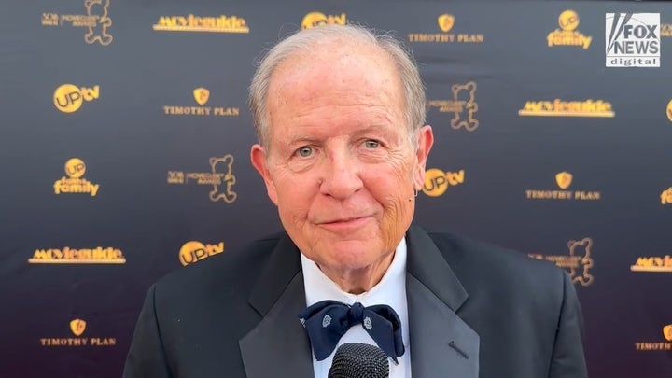Video
I often think about the Day of Pentecost when the Holy Spirit was first gifted to Jesus’s disciples. While they were consumed by tongues of fire and speaking in different languages, certain members of the crowd outside laughed and accused them of being drunk.
As believers, our response to the manifestation of the Holy Spirit might not be as brash as this example, but I think it’s fair to say that many of us have shied away from the very things that occupied the majority of Jesus’s earthly ministry such as healing the sick, and especially the casting out of demons.
I will be the first person to admit that the thought of casting out a demon makes me extremely uncomfortable–but Jesus did it and He commissioned His disciples to do the same through the Holy Spirit, so, realistically, why shouldn’t I believe He would want His modern-day Church to embrace the spiritual authority He bestowed upon us?
I'VE BEEN TO #ASBURYREVIVAL. IT'S REAL AND SPREADING. THIS IS WHAT I SAW
These gaps in our faith as "believers" are the very reason we need revivals like the one taking place at Asbury University.
The brokenness in our society is beyond repair on a strictly human level. We need God more than ever to intervene in ways only He can.
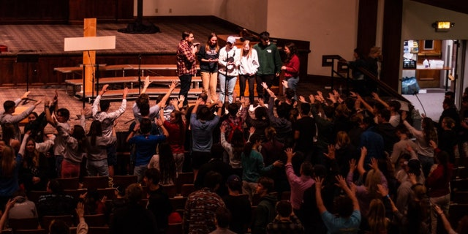
Students participate in a chapel service at Asbury University in Wilmore, Kentucky, which has seen worshipers pouring in nationwide. (Asbury University)
I’ve seen testimonies of people who have been amazed and mystified by things they’ve witnessed in the past week at Asbury–and while God will always do more than we could ever hope or imagine (Eph 3:20)--part of me longs for a day where the majority of Christians will see God’s direct actions in our world today and respond with less shock and more expectation for "even greater things" (John 14:12).
In the hit series portraying Jesus’s ministry, "The Chosen," the character of Jesus often says to His followers, "Get used to different."
As I continue to watch the events at Asbury unfold, this phrase comes to the forefront of my mind. Just as Jesus presented Himself very differently from the Messiah the Jews long expected, so too the Holy Spirit often surprises Christians in the way He manifests and works.
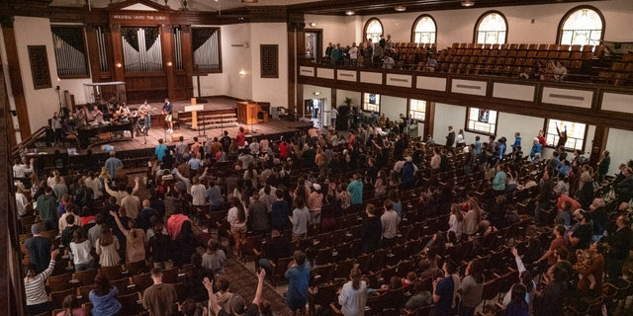
A packed chapel at Asbury University in Wilmore, Kentucky, shows worshipers participating in what some are calling a spiritual revival. (Asbury University)
His moves might not always feel "comfortable," at least, from the outset, and He might touch people who we never imagined He would. But we must never try to put our infinite God in a box of our finite expectations.
The key things we must remember are that where He is, there is freedom (2 Cor 3:17), and such freedom brings the fruits of love, joy, peace, patience, kindness, goodness, faithfulness, gentleness and self-control.
CLICK HERE TO GET THE OPINION NEWSLETTER
It is important to be wise as serpents, testing the fruit of said "moves of God" so that we are never led astray by any demonic influence, but let us also remember Jesus’s warning that "​​unless you change and become like little children, you will never enter the kingdom of heaven" (Matt 18:3).
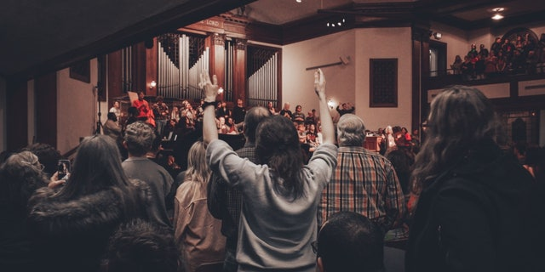
Students raise their hands during a service in the chapel at Asbury University, which has seen participants flocking in nationwide to witness its revival. (Asbury University )
We must remember God’s call to come to Him in humility, seeking to know every aspect of His nature. And we must also have faith that God can, and does, want to use His Holy Spirit in powerful ways in each of our individual lives.
In his book "Hearing God," Christian writer Dallas Willard speaks on the nature of gatherings in the first-century church and how we can look to them as our example today.
Noting 1 Corinthians 14, he writes, "we see that they assumed that numerous people in the congregation were going to have some kind of communication from God which they would be sharing with others in the group….the ancient prophecy of Joel was fulfilled in the early church: "Your sons and your daughters shall prophesy, and your young men shall see visions, and your old men shall dream dreams" (Acts 2:17,Joel 2:28-32).
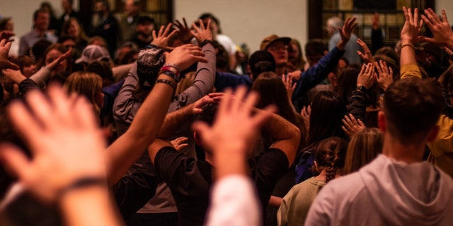
Worshipers lift their hands during a service in the chapel of Asbury University in Wilmore, Kentucky. (Asbury University)
The wish of Moses that "all the Lord’s people were prophets, and that the Lord would put His spirit on them" (Num 11:29) is substantially granted in the church of Jesus Christ when it functions as its Lord intended."
There you have it. When the church of Christ moves in faith-filled expectation, we operate in the fullness and reality of His Spirit living and working inside of us.
Whether you are a fiery revivalist or someone who is still on the fence about the Asbury University Revival, I pray that you will ask God to show you how you can be more open to the Holy Spirit manifesting in your life. It all starts there.
Christen Limbaugh Bloom is the co-author of "The Resurrected Jesus" and the creator of Haplous, a Christian blog and Bible study community. Her writing focuses on practical "baby steps" individuals can take while pursuing a deeper relationship with God. Christen lives with her husband, Sam, and their son in Texas. You can follow Christen’s blog on Instagram at @haplous_official and her website at www.haplousofficial.com. ​​​​​​

